Indoor Scavenger Hunt!
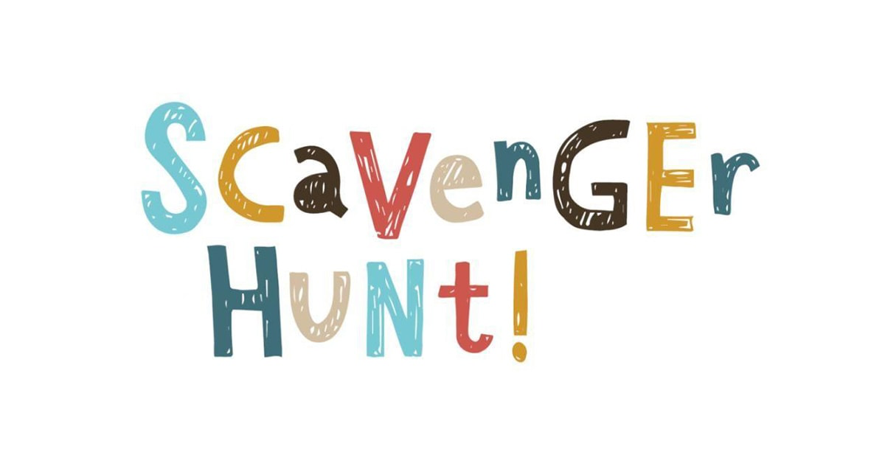

- An item that makes you feel cozy!
- A photo of someone you love!
- Your favorite stuffed animal!
- Your favorite book!
- A hat!
- A pillow!
- Something that starts with the first letter of your name!
- A spoon!
- A chair!

